Complete arrows
Government of

______________________
Type of Government
(Citizen Participation

Central government’s relationship
To regional government

_____________________________
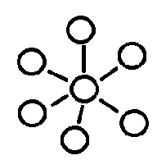

Who Carries
out the Law
Who decides what the laws mean
Who Makes the Laws

Legislative Branch Name

Executive Branch
Judicial Branch

Name of House Name of House Head of Government Head of State Name of High court
Number of members
How are members chosen?
How long are their terms?
Powers

Number of members
How are members chosen?
How long are their terms?
Powers
Title
Term
Powers
Title
Term
Powers

Other Details
When can people vote?

Government Vocabulary

Unitary

Federal

Confederal

Autocracy

Oligarchy

Democracy

Presidential Democracy

Parliamentary Democracy

Representative Democracy

Direct Democracy

